A SLEEP TRACKING APP FOR A BETTER NIGHTS REST

# INTRODUCTION

* 1. **Overview**

Irregular sleeping patterns are a common problem. This mobile app will fulfill the user's needs in tracking their sleeping patterns, including duration and timings. This app will track three parameters: sleep time, wake up time, and sleep duration. Users can add, edit, or remove any sleep entries.

# Purpose

This application enables you to start the timer when they are in the bed and about to fall asleep. The timer will keep running in the background until it is stopped, whenever the user wakes up. Based on the sleep experience, you can rate your sleep quality. Finally the app will display an analysis of the kind of sleep , you had the previous night.

# PROBLEM DEFINITION & DESIGN THINKING

* 1. **Empathy Map**

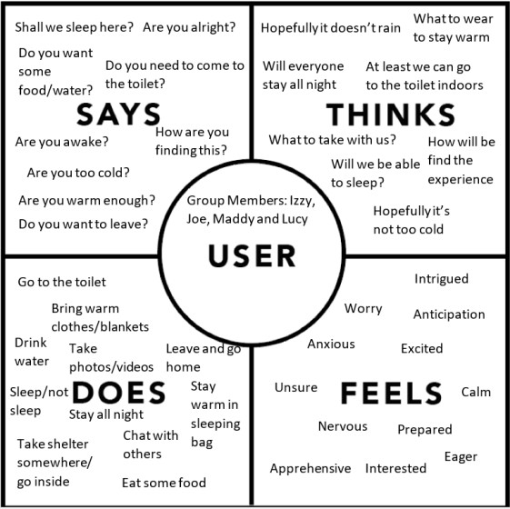

# Ideation & Brainstorming Map

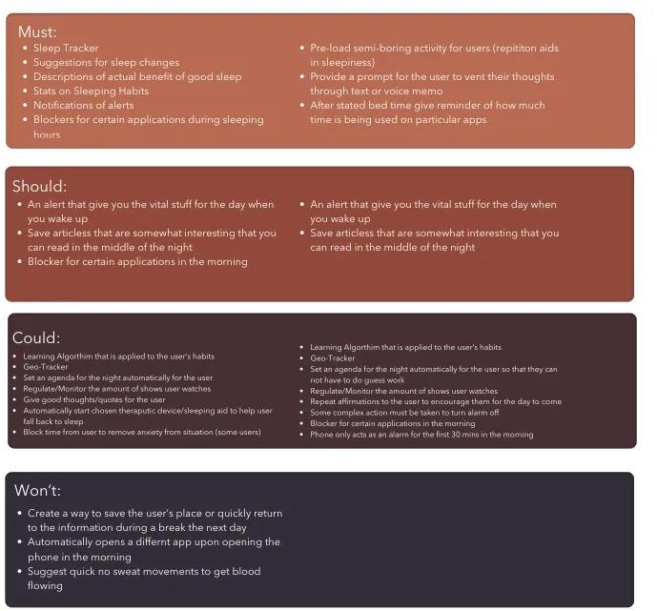

1. **RESULTS LOGIN SCREEN**

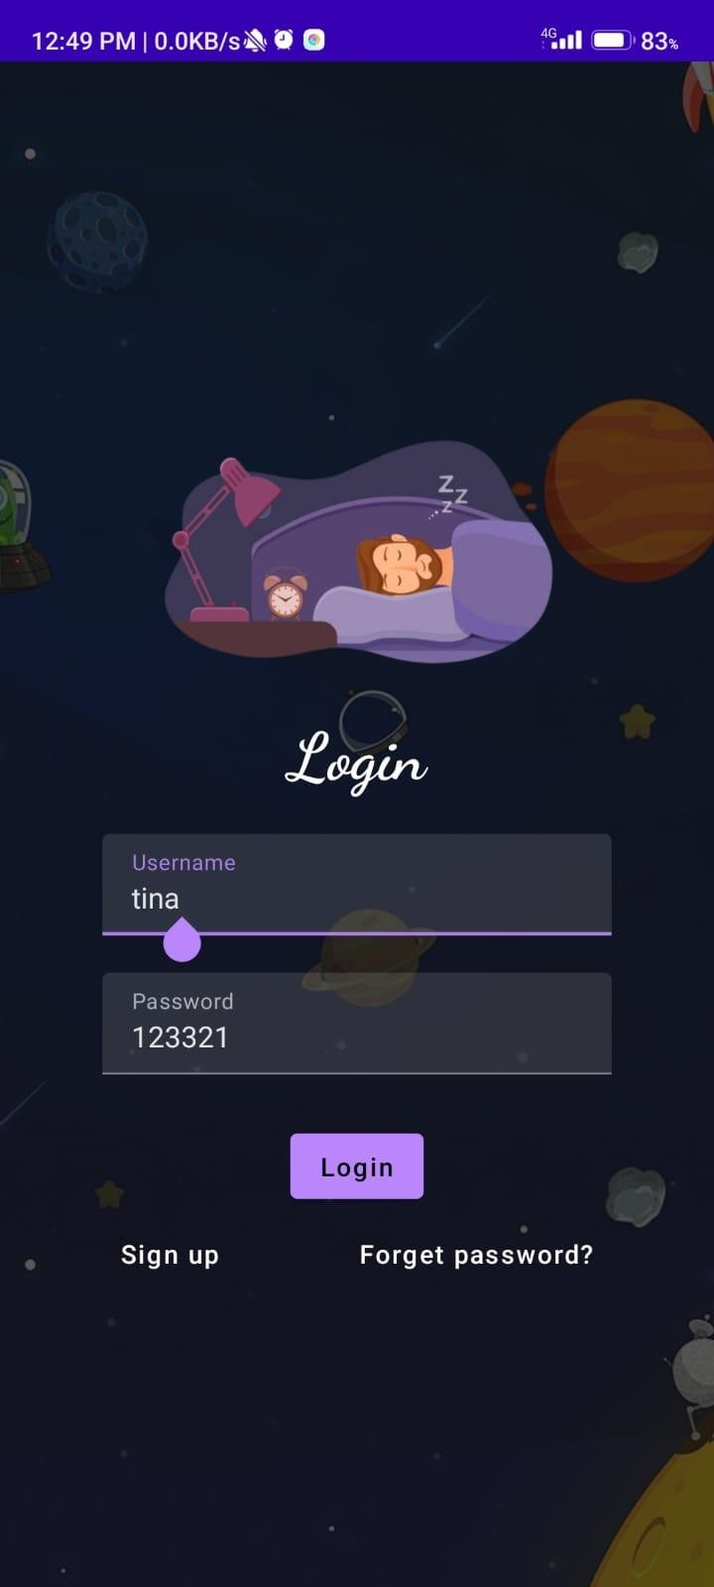

# SLEEP TRACK START SCREEN

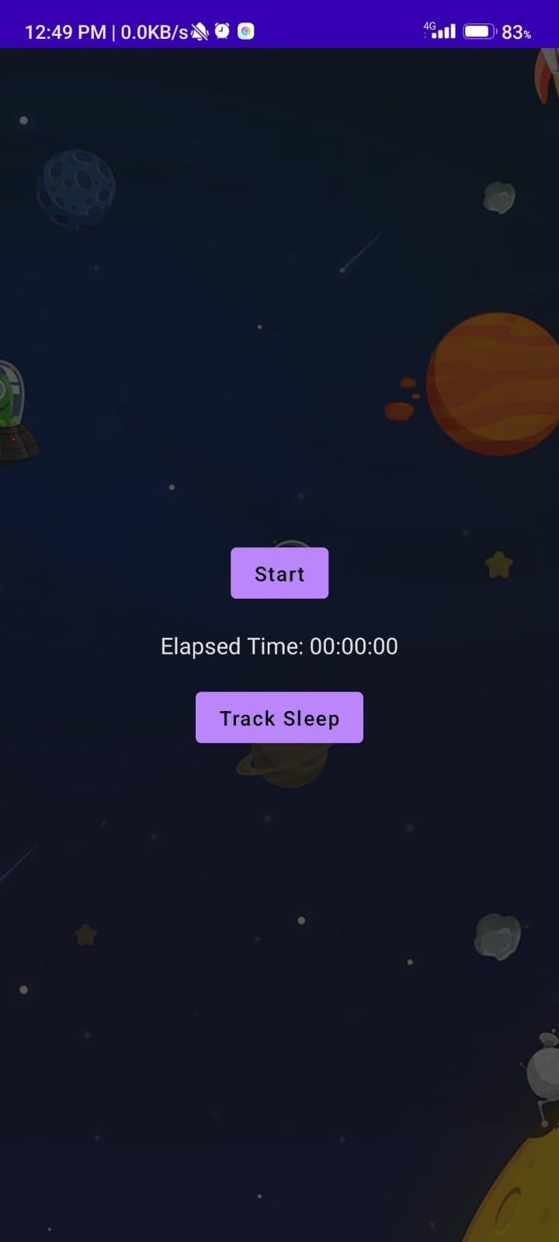

**SLEEP TRACK STOPED SCREEN**

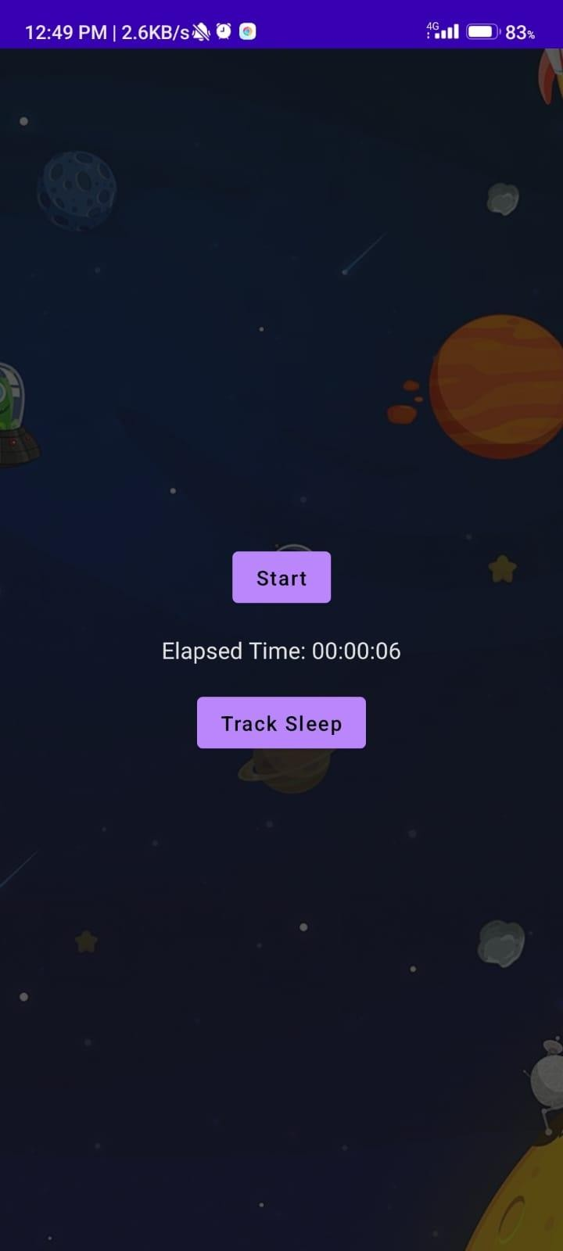

# SLEEP TRACKING SCREEN

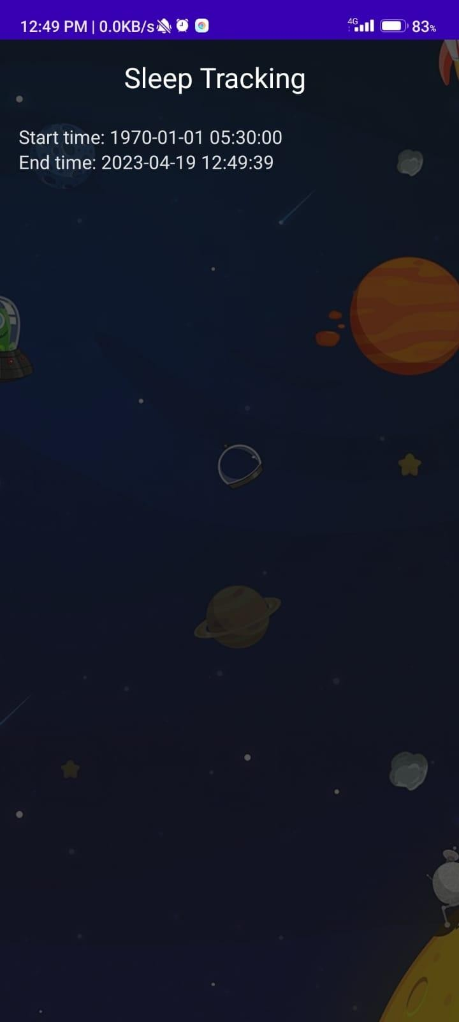

1. **ADVANTAGES & DISADVANTAGE**

# ADVANTAGES OF SLEEP TRACKER

Sleep trackers offer a variety of benefits for those looking to improve their quality and duration of sleep.

sleep trackers offer an invaluable benefit: heightened awareness. By diligently monitoring your sleep, these devices empower you to better understand your nocturnal habits.

Sleep trackers can prove to be incredibly insightful when it comes to detecting potential sleep issues. By closely monitoring your nightly rest, you can identify irregularities, such as sleep apnea or insomnia, which may have gone unnoticed otherwise.

Sleep trackers are designed to collect and analyze information over extended periods. They help you monitor trends and observe the effectiveness of interventions, like waking up consistently at the same time every day, reading a book before bed, or screening off two hours before bedtime.

# DISADVANTAGES OF SLEEP TRACKER

In the realm of sleep trackers, accuracy can be a hot topic since not all devices and apps are created equal, leading to varying degrees of precision. Of course, if your sleep tracker is inaccurate, that means the information you collect might cause you to make assumptions about your sleep habits that may not hold.

In the pursuit of better sleep, you may become overly fixated on numbers and metrics, inadvertently neglecting to listen to your body and address the underlying issues affecting your sleep.

# APPLICATIONS

A sleep tracker can make an educated guess about your sleep stages. But the only way to accurately identify what stage of sleep you are in.

Sleep tracking app track your sleep patterns and provide feedback on how to get better

sleep.

# CONCLUSION

Sleep trackers may be useful in improving user’s self-management, and increasing sleep hygiene awareness, knowledge and behaviours. Thus, apps may present valuable tools for improving sleep quality. It is recommended to assess behavioral changes associated with sleep trackers in different populations, such as elders, and people with sleep disorders and major illnesses.

Apps available for sleep tracking may be valuable tools to improving sleep quality, yet they require improvement in terms of quality and content, highlighting the need for further validity studies.

# FUTURE SCOPE

Sleep apps must undergo rigorous validation studies to ensure that their claims are evidence-based. These validation studies should compare the sleep data generated by the app with sleep data from a relevant gold-standard. Finally, the developers of sleep apps should listen to users and make the changes they recommend.

1. **APPENDIX**

# A. Source Code

package com.example.projectone

import android.content.Context import android.content.Intent

import android.icu.text.SimpleDateFormat import android.os.Bundle

import androidx.activity.ComponentActivity import androidx.activity.compose.setContent import androidx.compose.foundation.Image import androidx.compose.foundation.layout.* import androidx.compose.material.Button

import androidx.compose.material.MaterialTheme import androidx.compose.material.Surface import androidx.compose.material.Text

import androidx.compose.runtime.* import androidx.compose.ui.Alignment import androidx.compose.ui.Modifier import androidx.compose.ui.draw.alpha

import androidx.compose.ui.layout.ContentScale import androidx.compose.ui.res.painterResource import androidx.compose.ui.unit.dp

import androidx.core.content.ContextCompat

import com.example.projectone.ui.theme.ProjectOneTheme import java.util.*

class MainActivity : ComponentActivity() {

private lateinit var databaseHelper: TimeLogDatabaseHelper

override fun onCreate(savedInstanceState: Bundle?) { super.onCreate(savedInstanceState) databaseHelper = TimeLogDatabaseHelper(this) databaseHelper.deleteAllData()

*setContent* **{**

*ProjectOneTheme* **{**

// A surface container using the 'background' color from the

theme

*Surface*(

modifier = Modifier.*fillMaxSize*(), color = MaterialTheme.colors.background

) **{**

*MyScreen*(this,databaseHelper)

**}**

**}**

**}**

}

}

@Composable

fun MyScreen(context: Context, databaseHelper: TimeLogDatabaseHelper) { var startTime by *remember* **{** *mutableStateOf*(0L) **}**

var elapsedTime by *remember* **{** *mutableStateOf*(0L) **}**

var isRunning by *remember* **{** *mutableStateOf*(false) **}**

val imageModifier = Modifier

*Image*(

*painterResource*(id = R.drawable.*sleeptracking*), contentScale = ContentScale.FillHeight, contentDescription = "",

modifier = imageModifier

.*alpha*(0.3F),

)

*Column*(

modifier = Modifier.*fillMaxSize*(), horizontalAlignment = Alignment.CenterHorizontally, verticalArrangement = Arrangement.Center

) **{**

if (!isRunning) {

*Button*(onClick = **{**

startTime = System.currentTimeMillis() isRunning = true

**}**) **{**

**}**

} else {

*Text*("Start")

//databaseHelper.addTimeLog(startTime)

*Button*(onClick = **{**

elapsedTime = System.currentTimeMillis() isRunning = false

**}**) **{**

**}**

}

*Text*("Stop") databaseHelper.addTimeLog(elapsedTime,startTime)

*Spacer*(modifier = Modifier.*height*(16.*dp*))

*Text*(text = "Elapsed Time: ${*formatTime*(elapsedTime - startTime)}")

*Spacer*(modifier = Modifier.*height*(16.*dp*))

*Button*(onClick = **{** context.startActivity( Intent(

context, TrackActivity::class.*java*

)

) **}**) **{**

*Text*(text = "Track Sleep")

**}**

**}**

}

private fun startTrackActivity(context: Context) {

val intent = Intent(context, TrackActivity::class.*java*) ContextCompat.startActivity(context, intent, null)

}

fun getCurrentDateTime(): String {

val dateFormat = SimpleDateFormat("yyyy-MM-dd HH:mm:ss", Locale.getDefault())

val currentTime = System.currentTimeMillis() return dateFormat.format(Date(currentTime))

}

fun formatTime(timeInMillis: Long): String {

val hours = (timeInMillis / (1000 * 60 * 60)) % 24 val minutes = (timeInMillis / (1000 * 60)) % 60 val seconds = (timeInMillis / 1000) % 60

return String.*format*("%02d:%02d:%02d", hours, minutes, seconds)

}